Supporting Information
Org. Commun. X:X (202X) XX-XX
methyl 1-benzyl-5-(phenylamino)methyl)-1H-1,2,3-triazole-4-carboxylate

Guler YAGIZ ERDEMIR¹ and Aliye ALTUNDAS¹
¹ Department of Chemistry, Faculty of Science, Gazi University, 06560, Ankara, Turkey

Table of Contents | Page
Figure S1: FTIR Spectrum of Compound 4 | 2
Figure S2: ¹H-NMR Spectrum of Compound 4 | 2
Figure S3: ¹³C-NMR Spectrum of Compound 4 | 3
Figure S4: FTIR Spectrum of Compound 5a | 3
Figure S5: ¹H-NMR Spectrum of Compound 5a | 4
Figure S6: ¹³C-NMR Spectrum of Compound 5a | 4
Figure S7: FTIR Spectrum of Compound 5b | 5
Figure S8: ¹H-NMR Spectrum of Compound 5b | 5
Figure S9: ¹³C-NMR Spectrum of Compound 5b | 6
Figure S10: FTIR Spectrum of Compound 5c | 6
Figure S11: ¹H-NMR Spectrum of Compound 5c | 7
Figure S12: ¹³C-NMR Spectrum of Compound 5c | 7
Figure S13: FTIR Spectrum of Compound 5d | 8
Figure S14: ¹H-NMR Spectrum of Compound 5d | 8
Figure S15: ¹³C-NMR Spectrum of Compound 5d | 9
Figure S16: FTIR Spectrum of Compound 5e | 9
Figure S17: ¹H-NMR Spectrum of Compound 5e | 10
Figure S18: ¹³C-NMR Spectrum of Compound 5e | 10
Figure S19: FTIR Spectrum of Compound 5f | 11
Figure S20: ¹H-NMR Spectrum of Compound 5f | 11
Figure S21: ¹³C-NMR Spectrum of Compound 5f | 12
Figure S22: FTIR Spectrum of Compound 5g | 12
Figure S23: ¹H-NMR Spectrum of Compound 5g | 13
Figure S24: ¹³C-NMR Spectrum of Compound 5g | 13

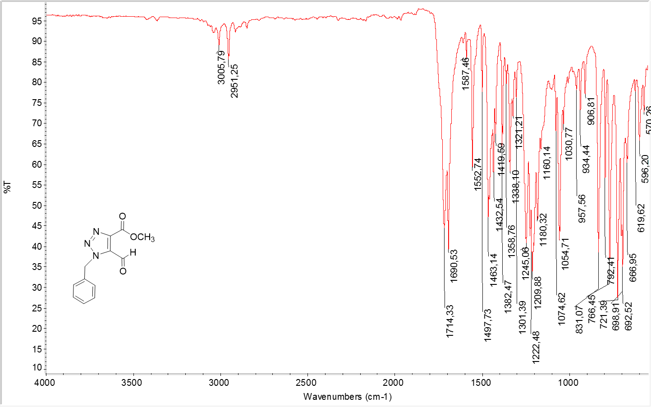
Figure S1: FTIR Spectrum of Compound 4

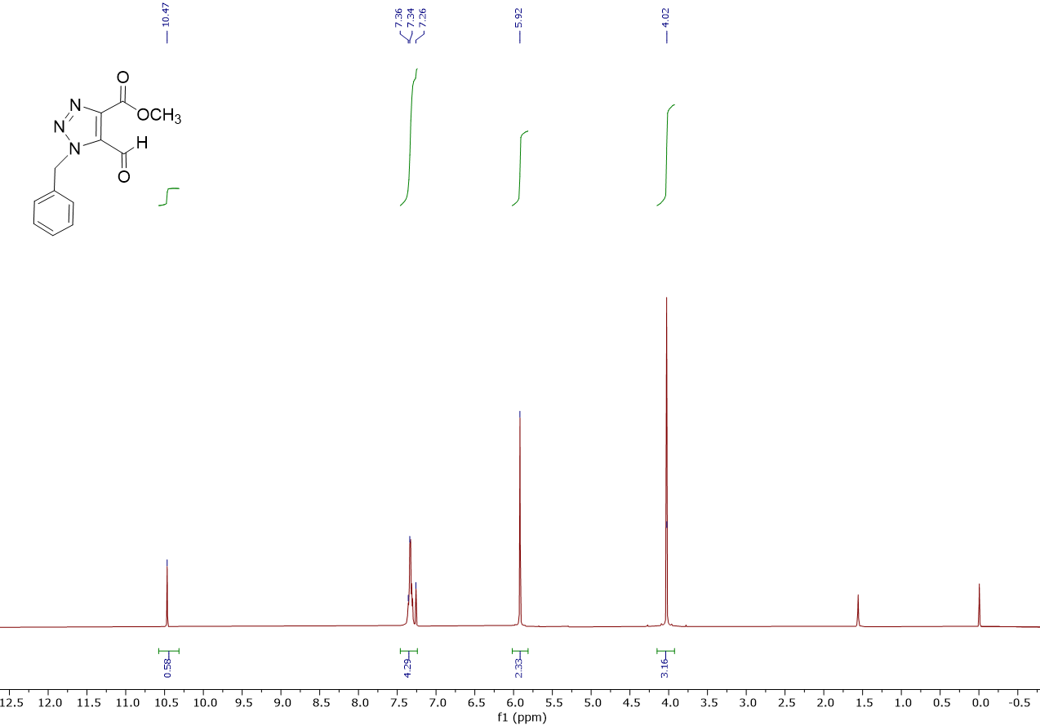
Figure S2: ¹H-NMR Spectrum of Compound 4

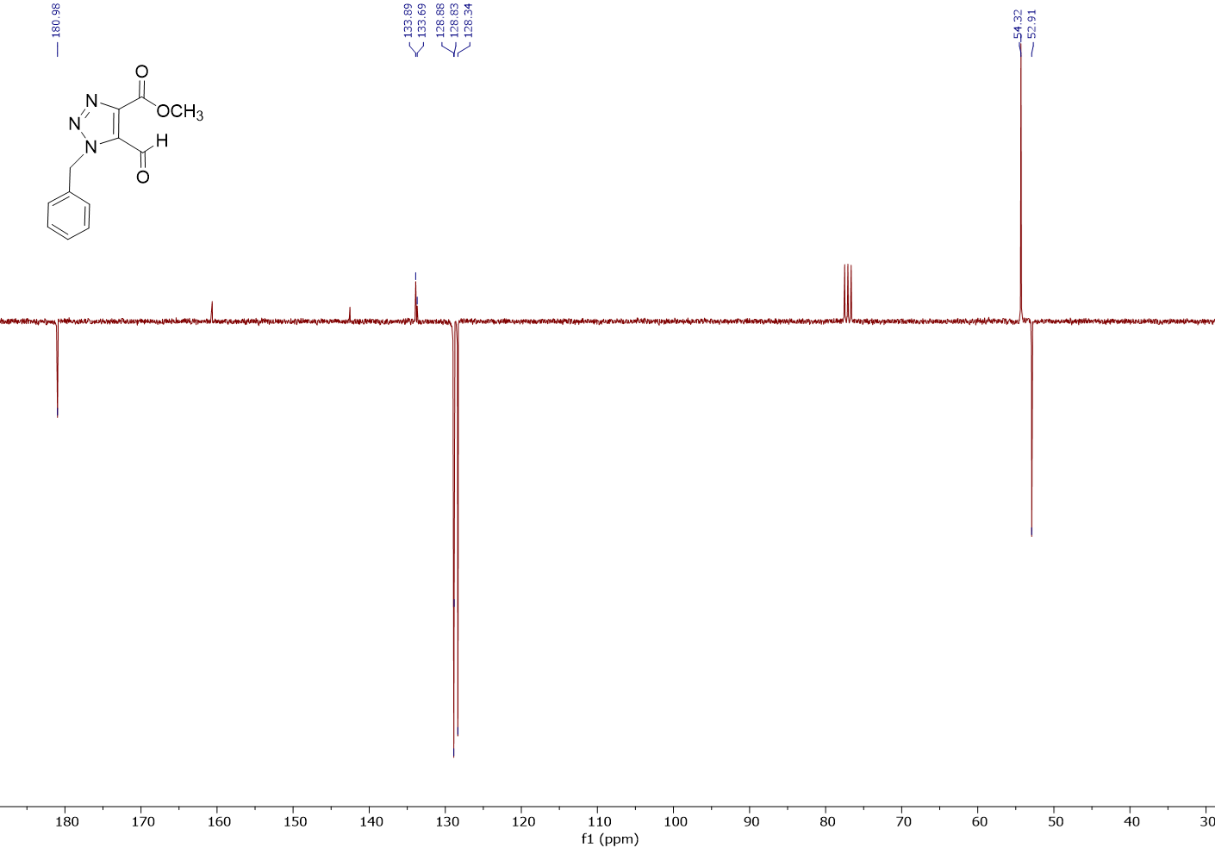
Figure S3: ¹³C-NMR Spectrum of Compound 4

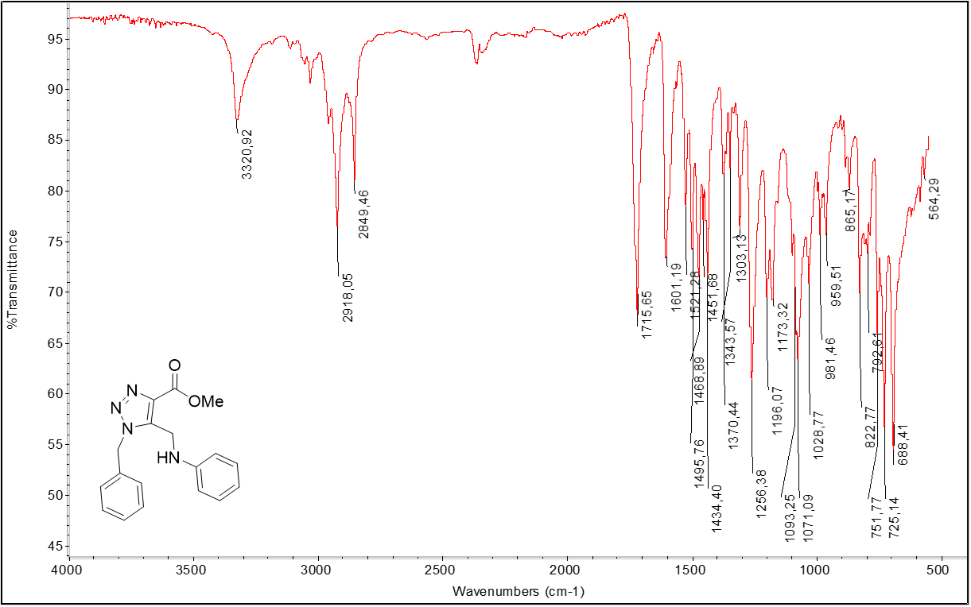
Figure S4: FTIR Spectrum of Compound 5a

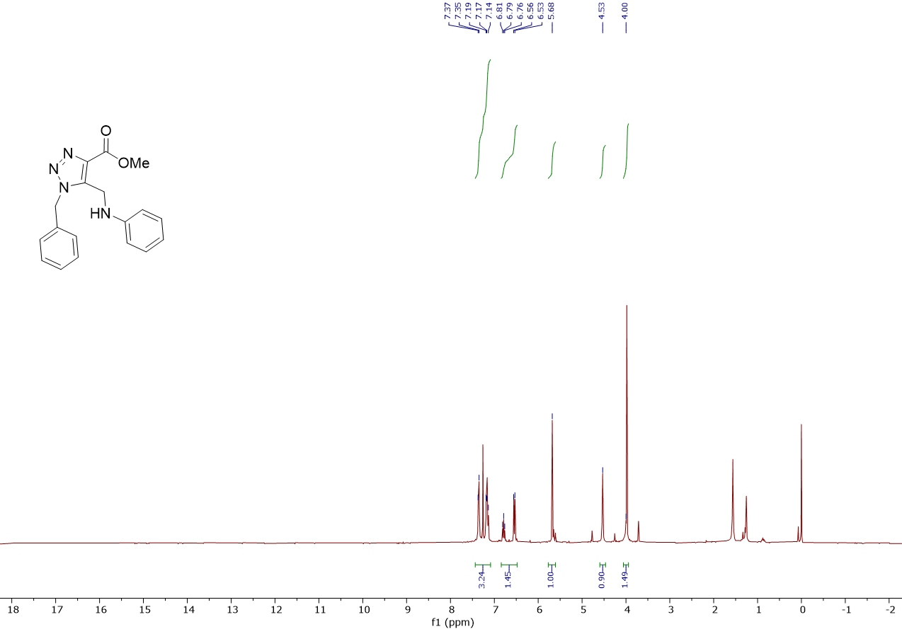
Figure S5: ¹H-NMR Spectrum of Compound 5a

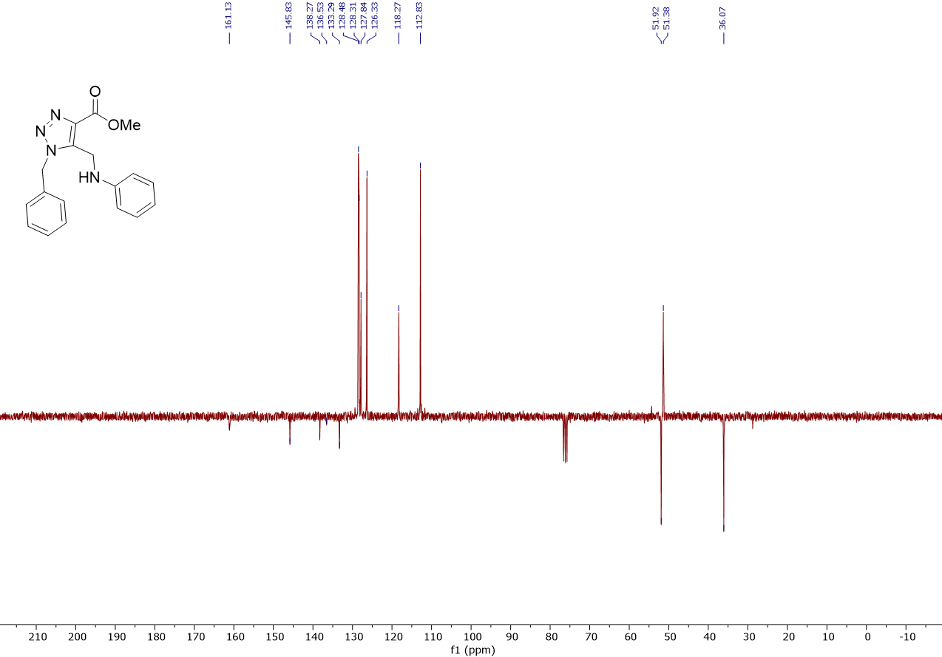
Figure S6: ¹³C-NMR Spectrum of Compound 5a
Figure S7: FTIR Spectrum of Compound 5b
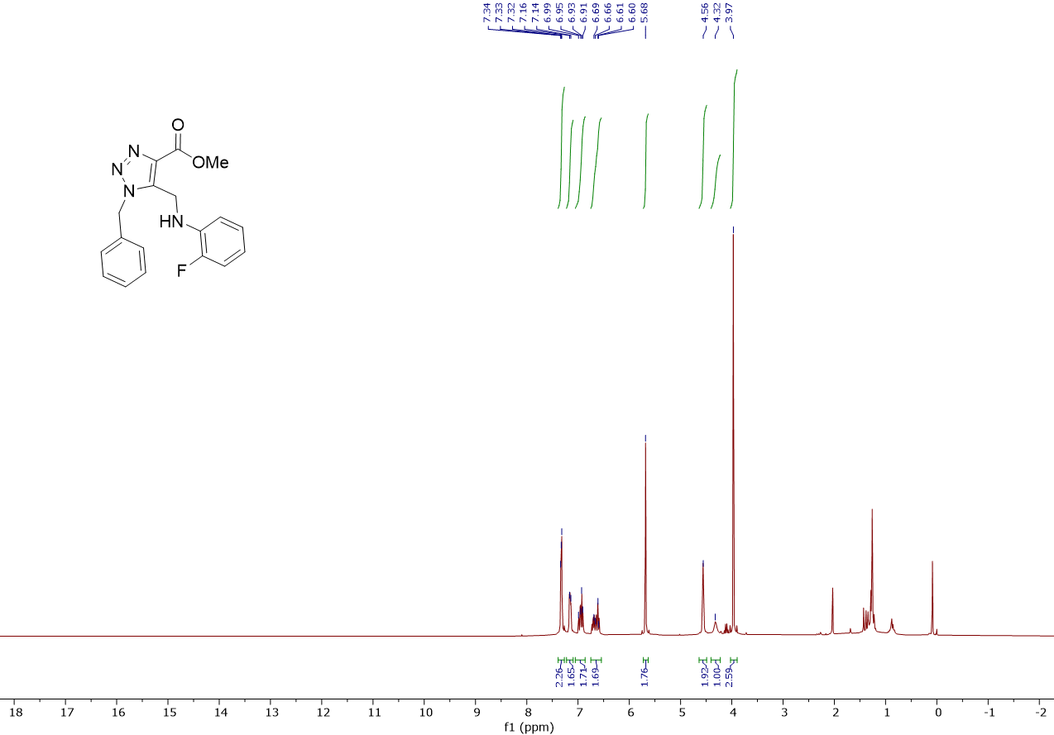
Figure S8: ¹H-NMR Spectrum of Compound 5b

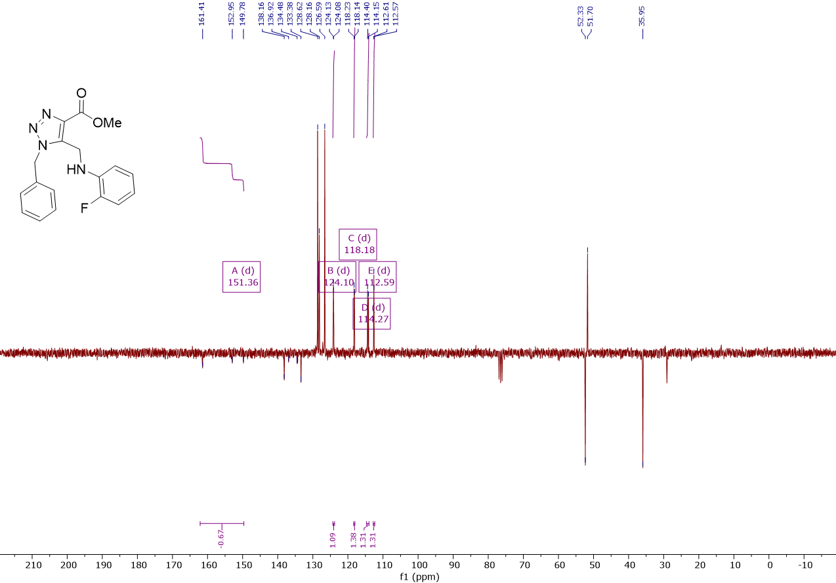
Figure S9: ¹³C-NMR Spectrum of Compound 5b

Figure S10: FTIR Spectrum of Compound 5c

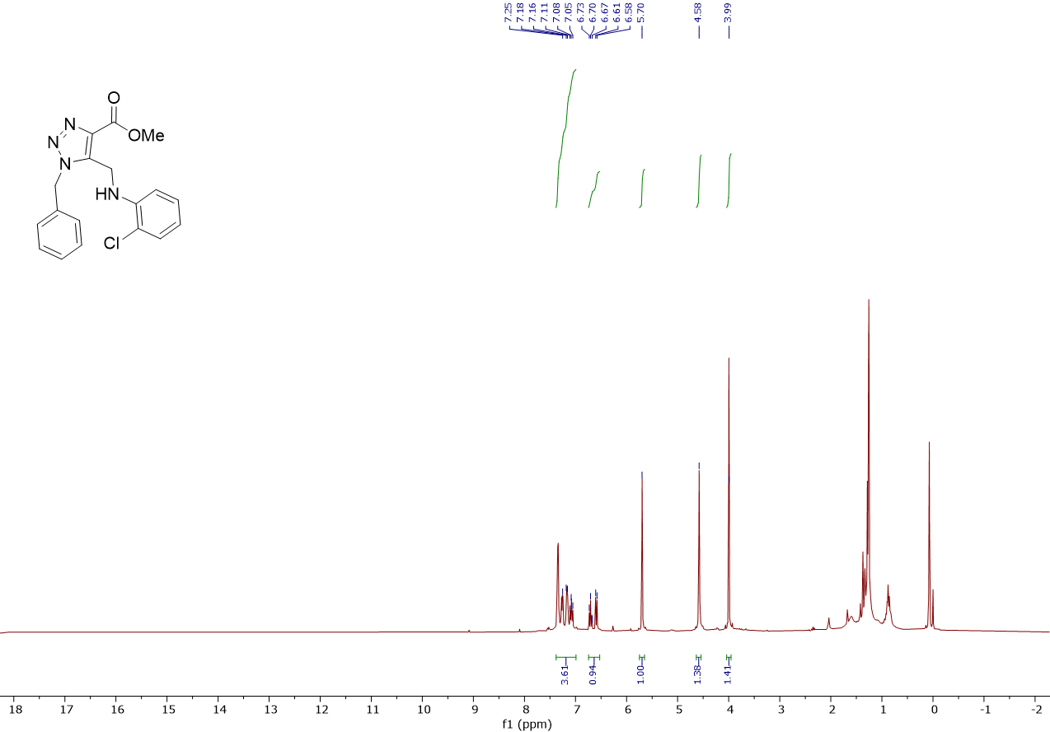
Figure S11: ¹H-NMR Spectrum of Compound 5c
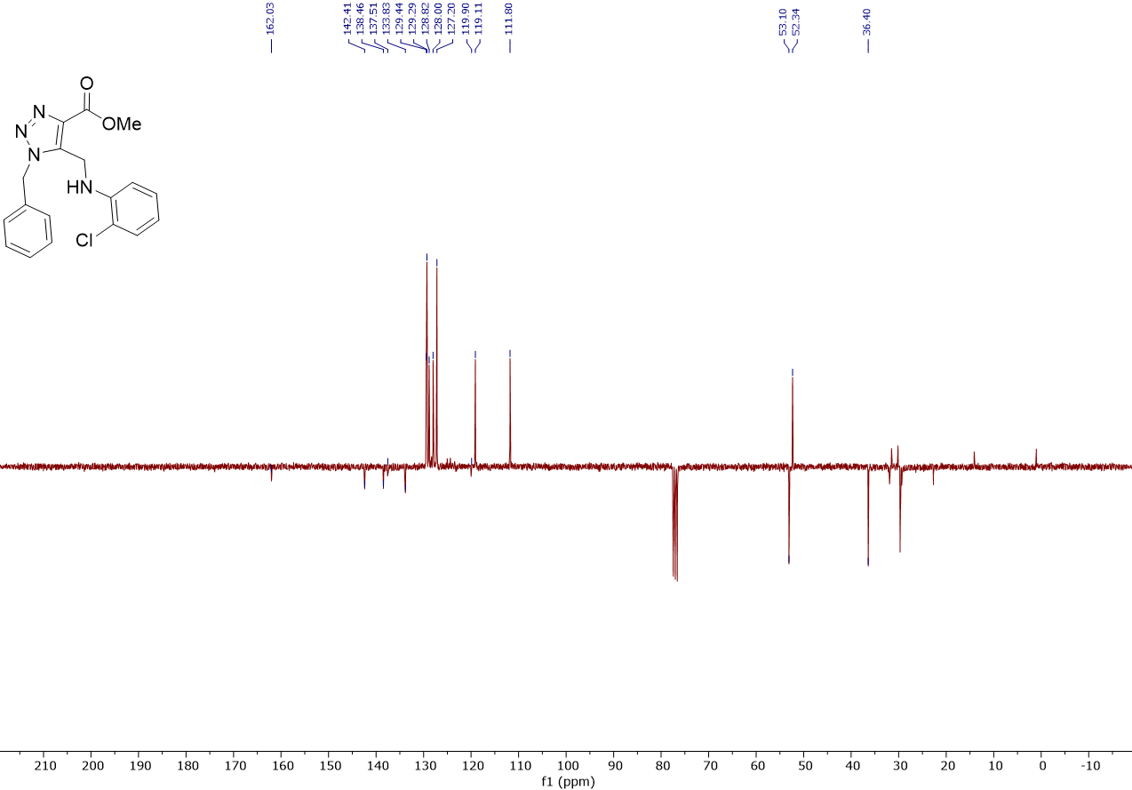
Figure S12: ¹³C-NMR Spectrum of Compound 5c

Figure S13: FTIR Spectrum of Compound 5d
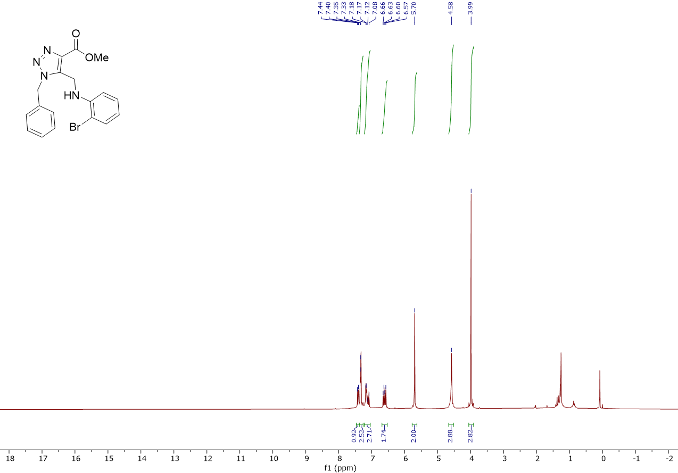
Figure S14: ¹H-NMR Spectrum of Compound 5d

Figure S15: ¹³C-NMR Spectrum of Compound 5d

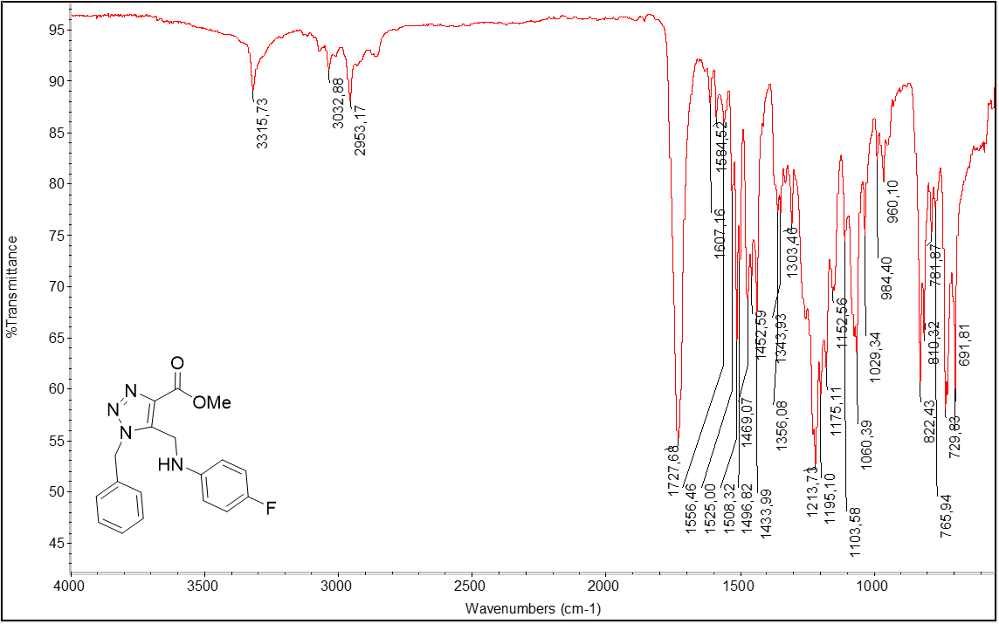
Figure S16: FTIR Spectrum of Compound 5e

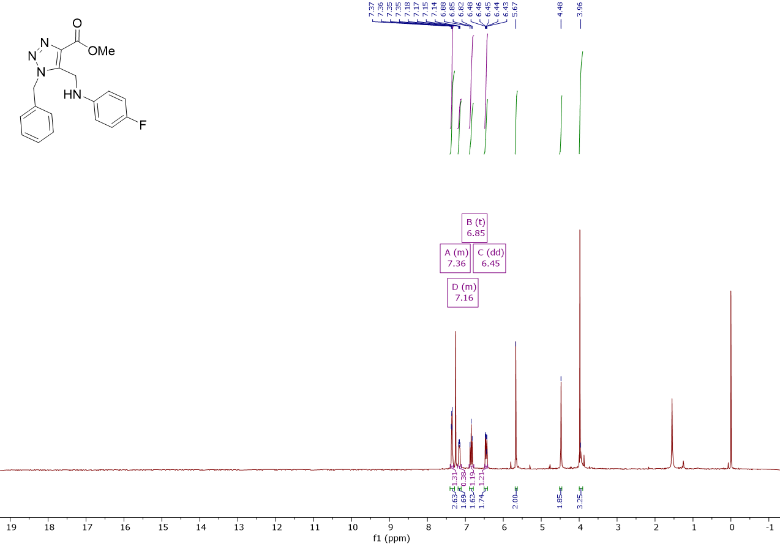
Figure S17: ¹H-NMR Spectrum of Compound 5e

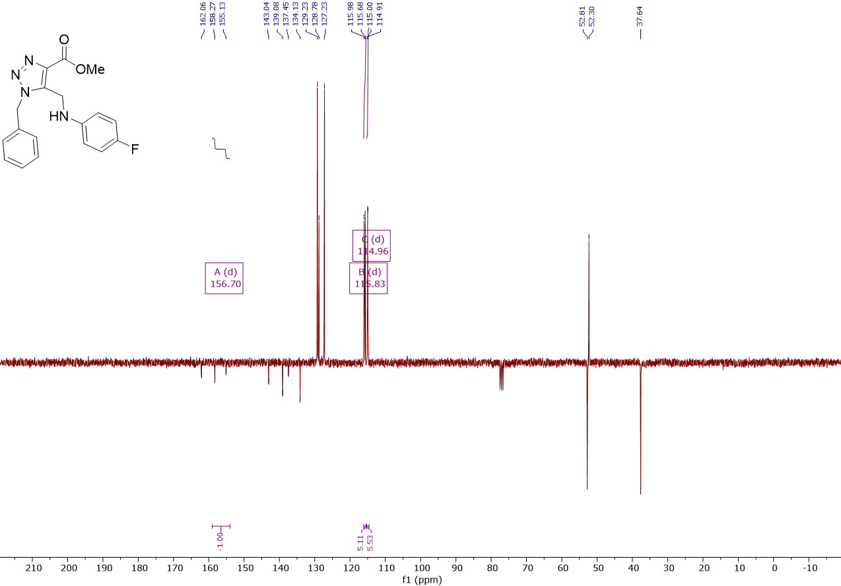,
Figure S18: ¹³C-NMR Spectrum of Compound 5e
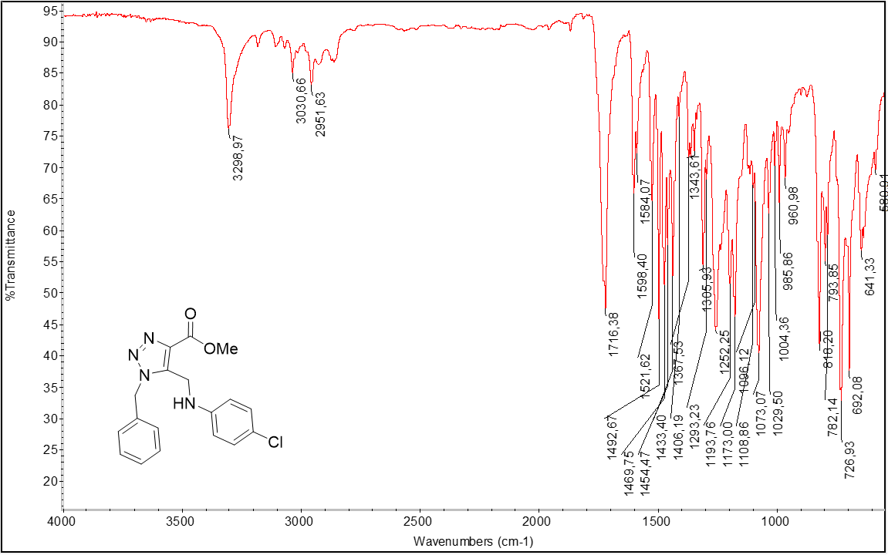
Figure S19: FTIR Spectrum of Compound 5f

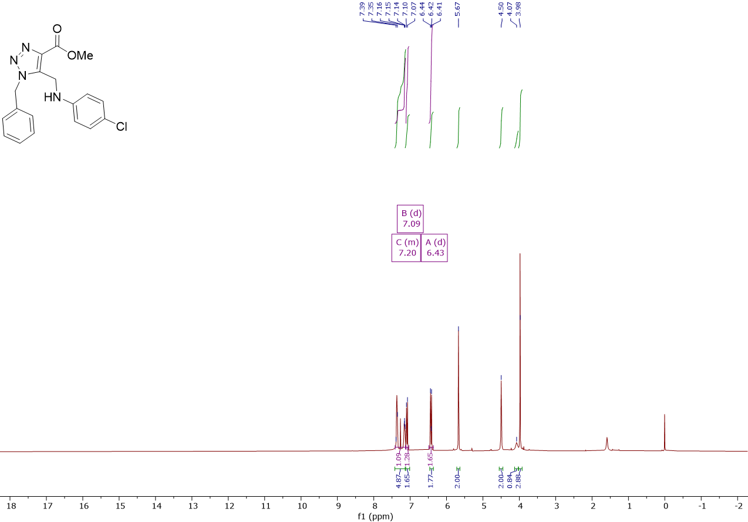
Figure S20: ¹H-NMR Spectrum of Compound 5f

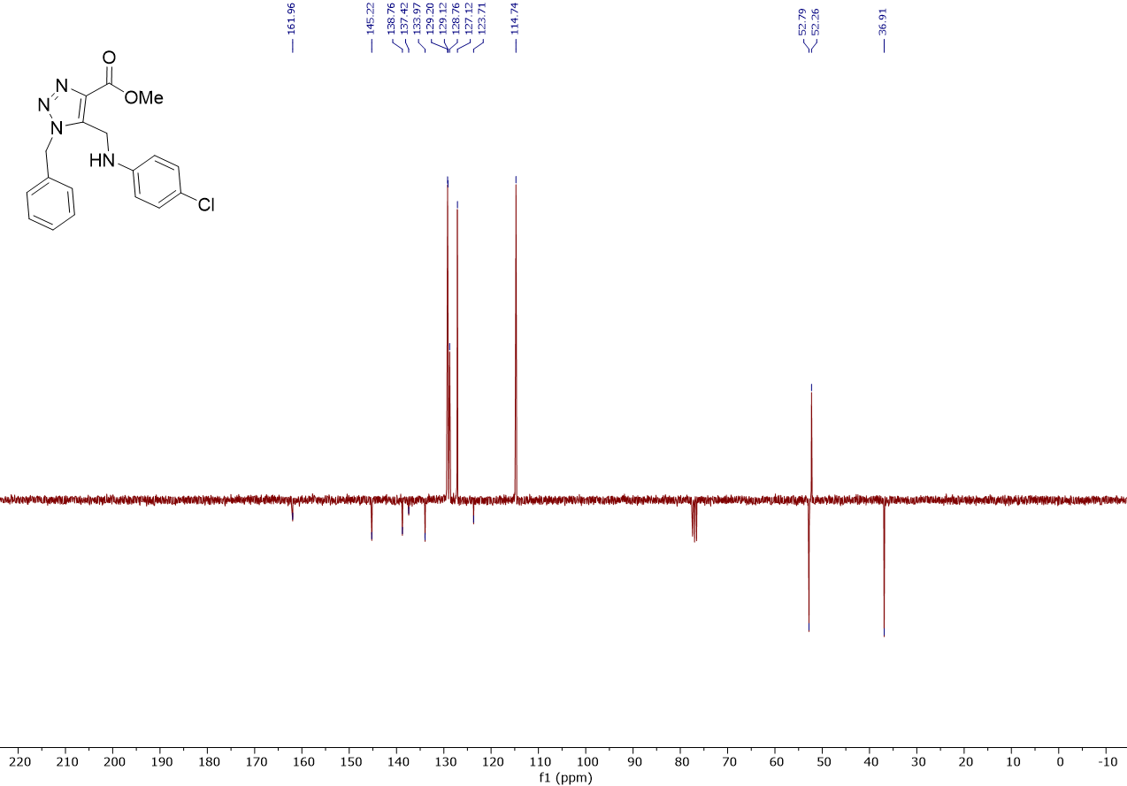
Figure S21: ¹³C-NMR Spectrum of Compound 5f

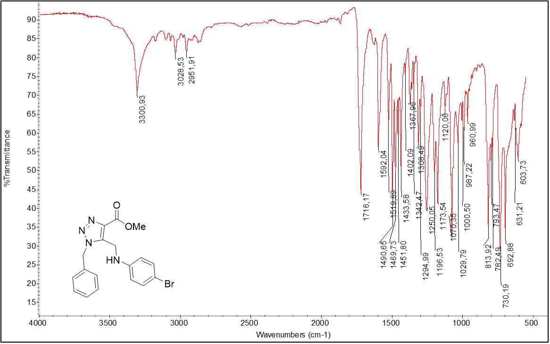
Figure S22: FTIR Spectrum of Compound 5g
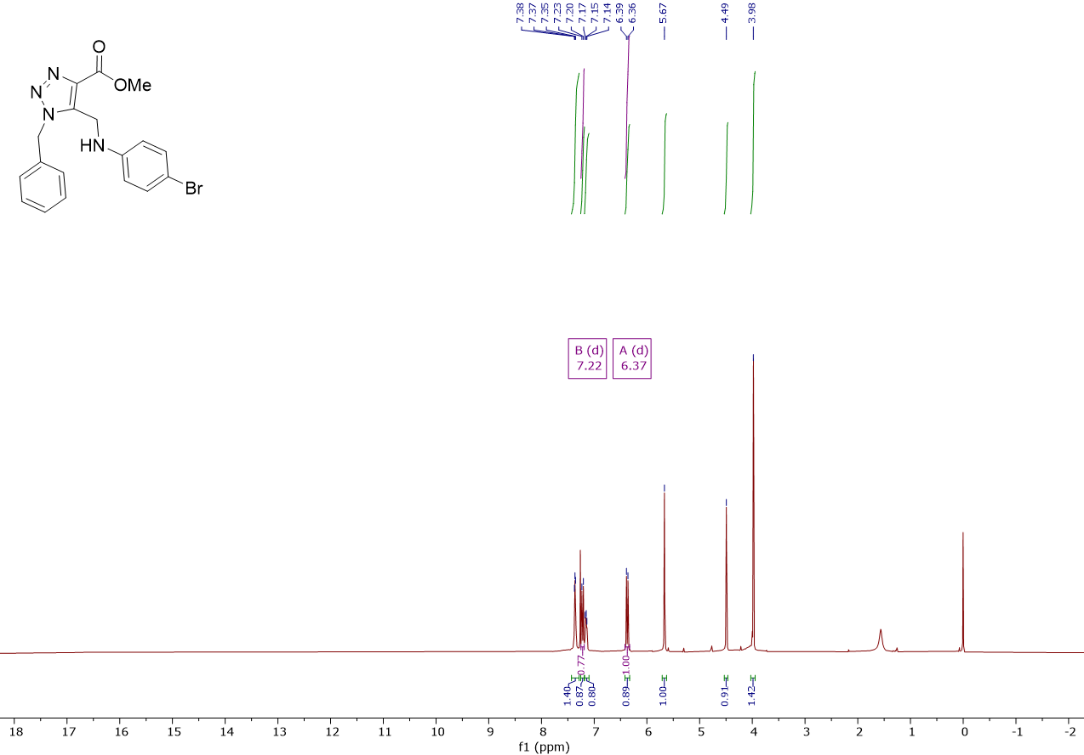
Figure S23: ¹H-NMR Spectrum of Compound 5g
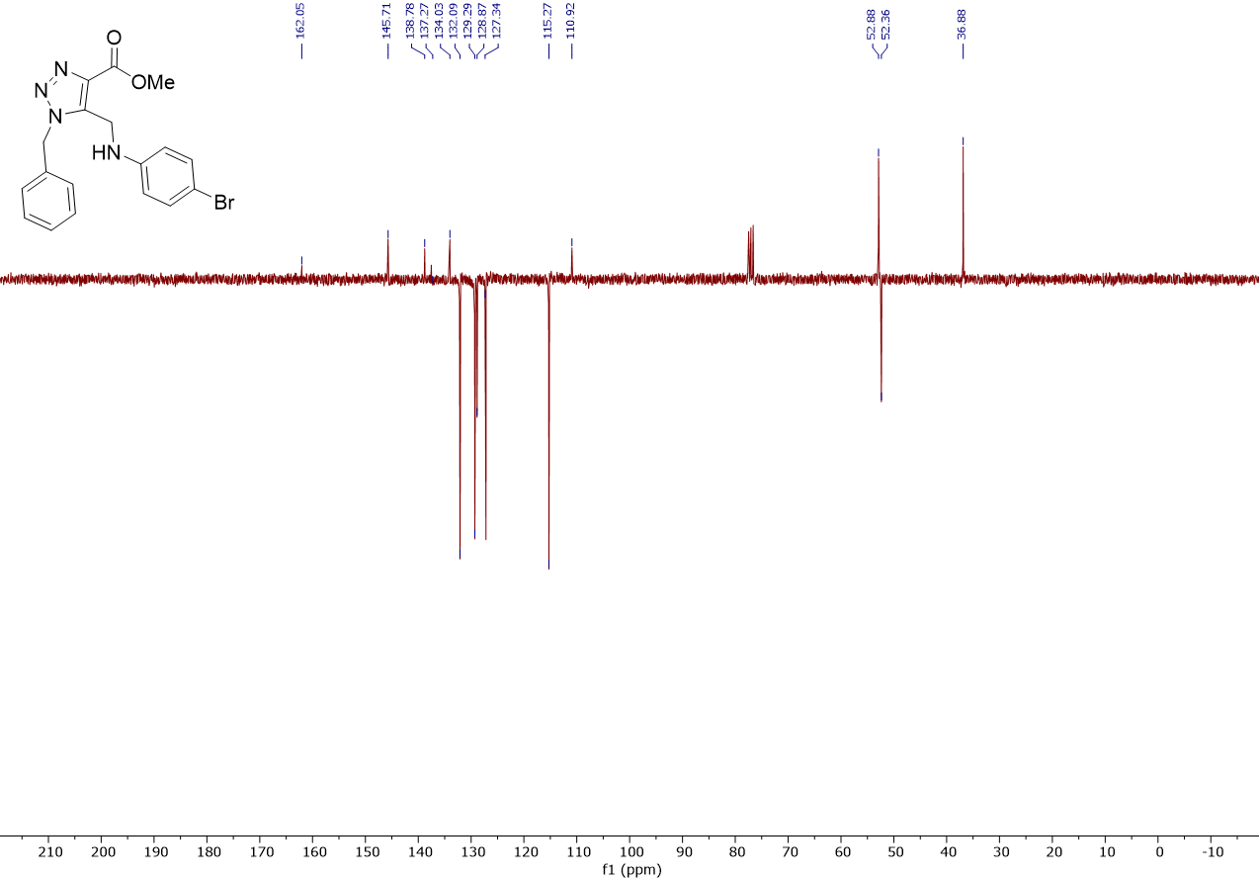
Figure S24: ¹³C-NMR Spectrum of Compound 5g

